Durward Copeland 9th Director December 1914 – April 1915
He had filled the chair of metallurgy at the School of Mines for seven years. He had been on leave of absence doing practical field work for a mining company in Llallagua, Bolivia.
He graduated from the Massachusetts Institute of Technology with the degree of S.B. in 1903. He was then made Assistant to Professor H. O. Hoffman, an Instructor in Metallurgy in the M.I.T. From 1904-07 he was Instructor in Metallurgy and Ore Dressing in the Michigan College of Mines and in 1907 he was called to the Professorship of Metallurgy in the Missouri School of Mines. He filled this position until 1913 when he was granted a leave of absence to do practical field work in mining in South America.
He arrived January 21, 1915 to assume his duties as Director of the School of Mines. Six members of the Board of Curators refused to recognize the Legislature’s authority as constitutional and forbade the School’s Executive Committee from sending out new catalogues which contained outlines of the new curricula or degree courses. This action tied the hands of the Committee and Faculty which led to Director Copeland to decide that he did not want to serve as Director under these conditions. The local citizens of Rolla had arranged a banquet, held in Mechanical Hall to welcome the new Director and celebrate the passage of the Buford Act on April 6, 1915. On April 8, 1915, he tendered his resignation to the Board of Curators. This action forced the Board to reinstate Professor Garrett as Acting Director. He was awarded the degree of Metallurgical Engineer at the May 1915 Commencement exercises. He left again to resume his field work in South America and severed his connection with the School of Mines in 1916.
A copy of the School of Mines advertisement, which the Board would not support however, was published in the 1915 Rollamo.
SEE BELOW
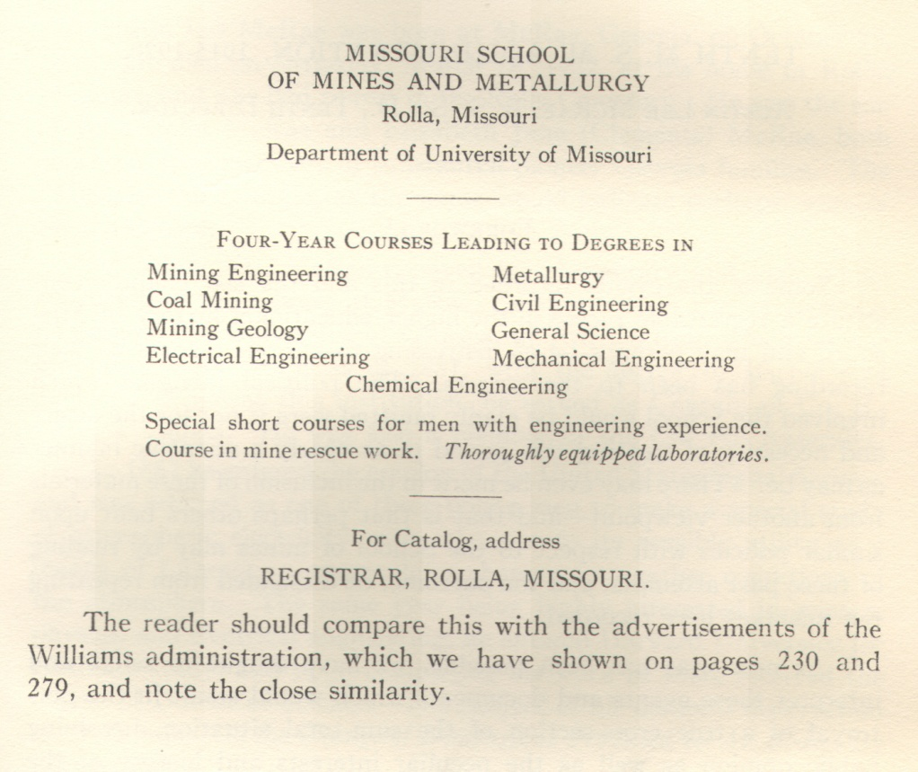
Buford Act – University of Missouri administration thought the School of Mines, that is, the courses in mining, metallurgy and civil engineering, ought to be moved to Columbia. The Visiting Committees of 1911 and 1913 recommended that “at some near future time the work of the institution (MSM) should be transferred to the State University, and this plant used for some other class of educational work or public purpose.” Director Copeland and Curator S.L. Baysinger wrote the Buford Act, which specified MS could offer “the bachelor of science and professional degrees in mining engineering, in metallurgy, in mechanical engineering, in electrical engineering, in chemical engineering, in civil engineering and the degrees of bachelor and master of science in general science.” Representative Frank Farris introduced it to the House of Representatives in the 1915 session. It became stalled in the House, so Baysinger persuaded Carter Buford, who represented the Rolla district in the Senate, to introduce it in the upper house. A petition was sent by the students of MSM to the General Assembly in support of the measure. It passed the Senate by a vote of 26 to 4, the House by a vote of 106 to 28, and was signed by Governor Major on March 23, 1915. The controversy over the Buford Act and criticism of his role in the matter caused him to resign his position as Director of MSM. The Board of Curators voted 5 to 3 against complying with the Buford Act. They felt it was their prerogative, not the legislature’s to establish curriculum in the University. MSM supporters took the Board to the Supreme Court of Missouri. A student named Harry T. Heimberger became the plaintiff. The Court ruled “that all the engineering science is not akin to, but is in aid to the mining engineer, and for this reason, if for no other, the Buford Act is not only a just and proper law, but a law that must be put in force, in order to carry out the original designs of the creator of the School of Mines, and to afford the best there is in the education and training of students in mining engineering and metallurgy.

